Kubernetes-Pod Scheduling
In creating a pod, the scheduling act as a controller.
The scheduling is responsible for assigning new create pods to appropriate nodes with in the cluster.
In Scheduling, if you want to prefer, you can create a new pod to run on purticular nodes.
There are several types of pod scheduling controls:
- NodeName
- NodeSelector
- Taint and Tolerance
- Affinity and Anti-Affinity
Node name
- Node name is the identifier of a node in a Kubernetes cluster.
- It's automatically assigned by the kubelet when the node joins the cluster.
- You can also manually schedule a pod to a specific node by setting spec.nodeName:
- nodeName is a field in the Pod spec that directly assigns the Pod to a specific Node.
- If you set it, the kube-scheduler is bypassed - the Pod will be placed only on that Node.
- Pods will only run on the Node named worker-01
- If that node is:
- Available & has resources → Pod runs there.
- Not available/doesn't exist / lacks resources → Pod stays Pending forever.
✔ NodeName vs NodeSelector (Quick Difference)
Feature | nodeName | nodeSelector
Scheduler Bypassed | Yes | No
Matches multiple nodes? | No | Yes
Best use case | Force Pod to one node | Label-based flexible scheduling

What is Node Name?
- Every node in Kubernetes has a unique node name.
- This name is automatically given by the kubelet when the node joins the cluster.

NodeName (Manual Scheduling)
You can manually schedule a pod on a specific node by specifying the nodeName field in the Pod specification. When a nodeName is given, the Kubernetes scheduler is bypassed and the pod is directly assigned to run on the node with the given name.

Here is an example Pod spec with nodeName:

apiVersion: v1
kind: Pod
metadata:
name: manually-scheduled-pod
spec:
nodeName: specific-node-name
containers:
- name: my-container
image: my-image

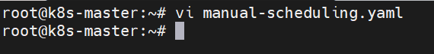
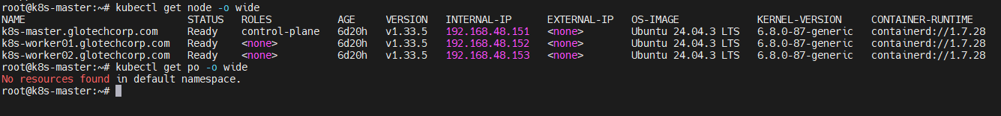
In this YAML:
- nodeName is set to specific-node-name, which is the name of the node where you want to schedule the Pod.
- name in containers is the name of your container.
- image in containers is the Docker image of your container.

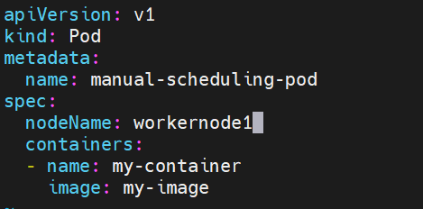

You would save this YAML in a file (say pod.yaml) and create the Pod using:
kubectl apply -f pod.yaml

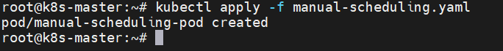

Now you have check where the pod is created:

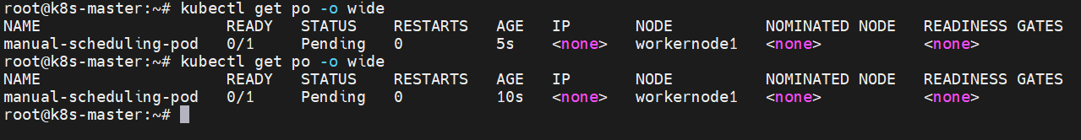

If I delete and create an pod also it defaultly create an pod in masternode1:

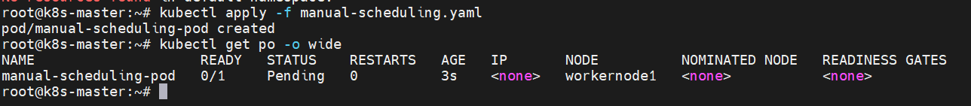

- If I delete and create an pod also it defaultly create an pod in workernode1(manually)
- Now once I manual sheduled to workernode1 and all other the shedule node will be located in workernode2

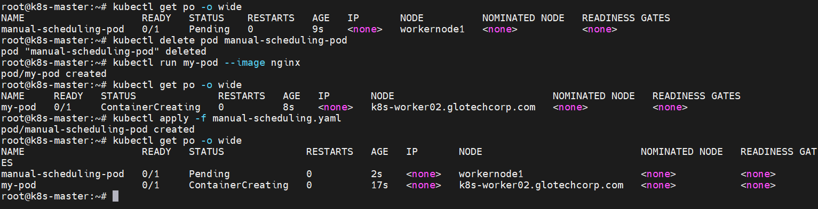

Please note that specifying a nodeName in the Pod spec is a form of direct pod scheduling. It bypasses the Kubernetes scheduler which means it does not take into account the various sophisticated scheduling features like resource-based scheduling, affinity and anti-affinity, taints and tolerations etc.
It's typically best to let Kubernetes automatically handle scheduling so it can balance resources across all nodes in the cluster.

Manual scheduling is generally used for specific scenarios where you need fine-grained control.
===========================================================================
What is Node Selector?
NodeSelector is the simplest method to force a Pod to run on specific nodes based on node labels.
✔ You add labels to nodes
✔ You use those labels inside the Pod spec
✔ The scheduler will place the Pod on nodes matching those labels

To Create nodeselector in yaml file:
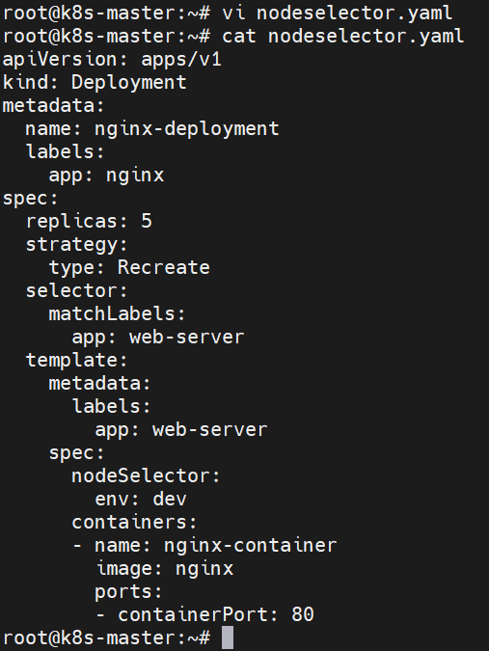
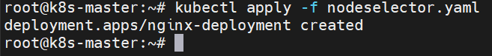
Verify the deployments and pods:
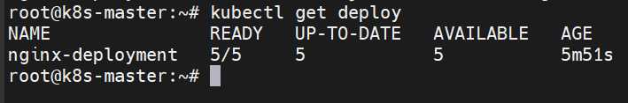
Label-based flexible scheduling
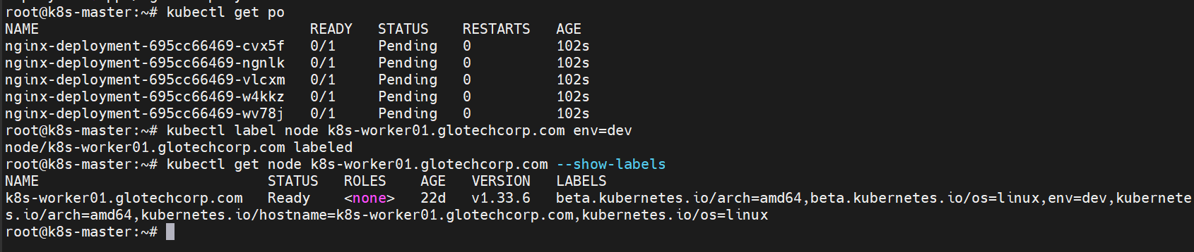
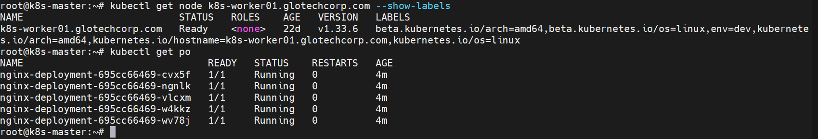
================================================================
Taints and tolerations
Taints and tolerations in Kubernetes are a way to ensure that Pods are not scheduled onto inappropriate nodes. They allow a node to repel a set of pods and can be used to implement dedicated nodes or special configurations.
- Taints are applied to nodes and signal that the node should not accept any pods that do not tolerate the taint.
- Tolerations are applied to pods and allow (but do not require) the pods to schedule onto nodes with matching taints.
What is a Taint?
A taint is applied on a Node.
It tells Kubernetes:
“Do NOT schedule Pods here unless they have matching toleration.”
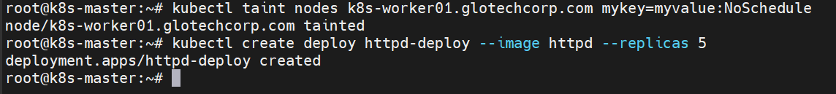
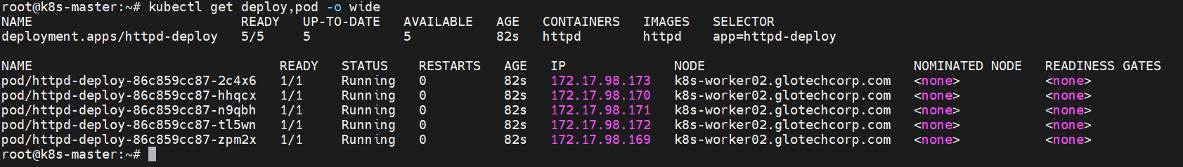
With this taint, no new pods will be able to schedule onto k8s-worker02.glotechcorp.com unless they have a matching toleration.

What is a Toleration?
A toleration is added to a Pod.
It tells Kubernetes:
“This Pod is allowed to run on Nodes that have this taint.”
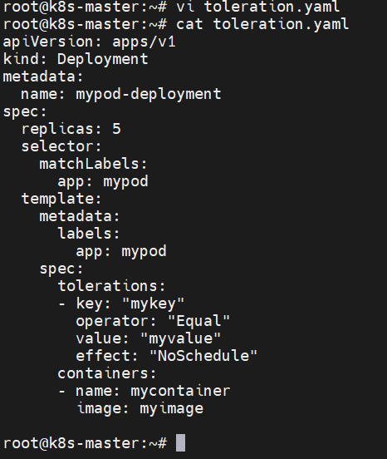
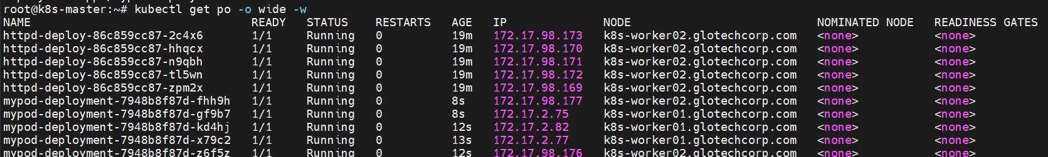
-------------------------------------------------------------------------------------------------------------------------------------
Taint Effect | Behavior
NoSchedule | Pods without toleration are not allowed to run on the node
PreferNoSchedule | Kubernetes tries to avoid this node but can schedule pods if needed
NoExecute | Evicts running pods and prevents new pods unless tolerated

1. NoSchedule – Strict Blocking (Do NOT schedule pods here)
Definition:
Pods without matching tolerations will NOT be scheduled on the node.
Kubernetes completely prevents new pods from running on this node unless they tolerate the taint.
✔ Existing running pods remain
❌ New pods without toleration cannot be placed on the node
Meaning: Hard restriction – “Do not schedule here.”
2. PreferNoSchedule – Soft Avoidance (Try not to schedule pods here)
Definition:
Kubernetes will try to avoid scheduling pods on this node, but it is allowed if no better node is available.
✔ Scheduler prefers other nodes
✔ Can still schedule pods here if required
❌ Not a strict block
Meaning: Soft preference – “Prefer not to schedule here, but allowed.”
3. NoExecute – Evict Existing Pods + Block New Pods
Definition:
Pods without toleration are evicted from the node, and new pods without toleration are not allowed to run on the node.
✔ Removes already running pods
✔ Blocks new pods
✔ Toleration may include tolerationSeconds (delay eviction)
Meaning: Eviction rule – “Do not run here AND remove existing pods.”

✅ 1. NoSchedule – Pods will NOT schedule unless they have matching toleration

Step 1: Apply NoSchedule taint
kubectl taint nodes k8s-worker01.glotechcorp.com key1=value1:NoSchedule

Step 2: Create a pod WITHOUT toleration
kubectl run test-noschedule --image=nginx
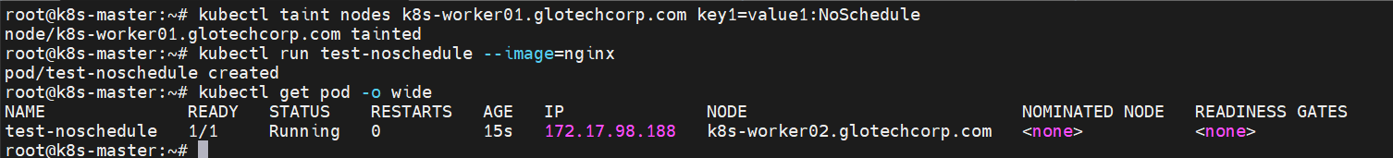
👉 Pod will not schedule on tainted node, it will go to other nodes.

✅ 2. PreferNoSchedule – Try NOT to schedule, but allowed

Step 1: Add PreferNoSchedule taint
kubectl taint nodes k8s-worker02.glotechcorp.com key2=value2:PreferNoSchedule

Step 2: Create a pod WITHOUT toleration
kubectl run test-prefer --image=nginx

👉 Behavior:
- Kubernetes will prefer other nodes
- But if no better node is available, it can still schedule on the tainted node
Check:
kubectl get pods -o wide
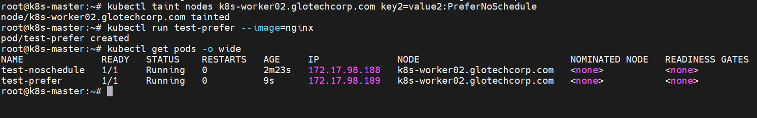

✅ 3. NoExecute – Immediately remove existing pods

Step 1: Add NoExecute taint
kubectl taint nodes k8s-worker01.glotechcorp.com key3=value3:NoExecute

Behavior:
- All existing pods without toleration on that node → evicted immediately
- New pods without toleration → will NOT schedule

Step 2: Test with a pod
Run a pod on worker01 before taint:
kubectl run test-noexecute --image=nginx --overrides='
{
"spec": {
"nodeName": "k8s-worker01.glotechcorp.com"
}
}'
Now apply the taint again:
# kubectl taint nodes k8s-worker01.glotechcorp.com key3=value3:NoExecute
👉 Pod will get evicted within seconds.
Check:
# kubectl describe pod test-noexecute

